**DATTA MEGHE COLLEGE OF ENGINEERING**



**(AICTE & Govt. Of Maharashtra Recognized, Affiliated To**

**University Of Mumbai)**

**Sector-3, Airoli, Navi Mumbai – 400 708, (M.S.), INDIA**

**Department of Information Technology Engineering**

Name of the Candidates: Akshata Pawar (B1-12)

Prajna Purthan (B1-16)

Saumya Prasad (B1-14)

Title of the Project : Smart Dustbin using Arduino

Year of Admission : 2019-2020

Name of the Guide : Prof. Vidya Kubde

Date of Submission of Outline : 11/02/2022

CONTENT Page no.

ABSTRACT ……………………………………………... 3

1) Project Introduction………………………………………4

2) Problem Definition………………………………………..5

3) Scope of Project…………………………………………...6

4) Background Study……………………………………...….6

5) System Design…………………………………………….7

5.1) Required Components…………………………………..8

1. 5.2) Required Software…………………………………………8
2. 5.3) Required Hardware…………………………………………8

6) Circuit Diagram……………………………………………..10

7) Working………………………………………………………11

8) Advantages……………………………………………………11

9) Future Enhancements………………………………………….12

10) Bibliography…………………………………………………..12

**Abstract**

The main objective of the project is to design a smart dustbin which will help in keeping our environment clean and also eco-friendly. We are inspired from Swachh Bharat Mission. Nowadays technologies are getting smarter day-by-day so, as to clean the environment we are designing a smart dustbin by using Arduino. This smart dustbin management system is built on the microcontroller based system having ultrasonic sensors on the dustbin. If dustbin is not maintained than these can cause an unhealthy environment and can cause pollute that affect our health.

In this proposed technology we have designed a smart dustbin using ARDUINO UNO, along with ultrasonic sensor, servo motor, and battery jumper wire. After all hardware and software connection, now Smart Dustbin program will be run. Dustbin lid will when someone comes near at some range than wait for user to put garbage and close it. It’s properly running or not.

For social it will help toward health and hygiene, for business for we try to make it affordable to many as many possible. So that everyone including normal people to rich people can take benefit from it.

Keywords: *arduino, microcontroller, IOT, circuitry,*

**Project Introduction**

Dustbins (or Garbage bins, Trash Cans) are small plastic or metal containers that are used to store trash (or waste) on a temporary basis. They are often used in homes, offices, streets, parks etc. to collect the waste.

In some places, littering is a serious offence and hence Public Waste Containers are the only way to dispose small waste.

Usually, it is a common practice to use separate bins for collecting wet or dry, recyclable or non-recyclable waste.

In this project, we have designed a simple system called Smart Dustbin using Arduino, Ultrasonic Sensor and Servo Motor, where the lid of the dustbin will automatically open itself upon detection of human hand.

The project aims at maintaining a clean and a hygienic environment and also avoiding attracting harmful germs and bacteria while using your hands or feet to open the lid of a Dustbin.

It is an IOT based project that will bring a new and smart way of cleanliness. It is a decent gadget to make your home clean, due to practically all offspring of home consistently make it grimy and spread litter to a great extent by electronics, rappers and various other things.

Since the smart dustbin is additionally intriguing and children make fun with it so it will help to maintain cleanliness in home.

**Problem Statement**

The rate increasing population in our country has increasing rapidly and also we have increase in garbage which have increased environmental issue.

Dustbin is a container which collects garbage’s or stores items which recyclable or non-recyclable, decompose and non-decompose. They are usually used in homes, office etc, but in case they are full no one is there to clean it and the garbage are spilled out.

The surrounding of a dustbin is also conducive for increasing the pollution level. Air pollution due to a dustbin can produce bacteria and virus which can produce life harmful diseases for human.

Therefore, we have designed a smart dustbin using ARDUINO UNO, ultrasonic sensor which will sense the item to be thrown in the dustbin and open the lid with the help of the motor.

It will be applied for various type of waste. Dustbin will open its lid when someone/object is near at some range then it will wait for given time period than it will close automatically. Here lid will close when you don’t want to use and it will only open when it required.

The project aims at making lesser use of hands or feet to open the Dustbin Container in order to avoid attracting harmful germs and bacteria.

**Scope of the Project**

This system can be set-up anywhere as this system is eco-friendly, technology-friendly and cost-effective.

This project can be set up in the houses of the normal people as it is cost-effective .

Our system is easy – to – use and has a lot of scope in the future and also in today’s generation to maintain public hygiene.

**Background**

Previous systems and systems in use in today’s generation of disposing garbage in a public area included only setting up of Dustbins and sometimes two different garbage bins for throwing Dry and Wet garbage.

For this, people use their hands and feet to open the lid of the garbage bins in order to dispose the garbage. This, in itself, has its disadvantages like – the air above and near by about the garbage bins is contaminated and contain disease spreading flee and germs and bacteria which is harmful for the human health.

Also, people using their hands and feet to open the lid of the dustbins may get infected, especially in this Covid-19 time frame where there’ll lead to contact due to touching the bins or the pedals of the dustbins .

The new proposed system overcomes all these cons which comes with contact-full dustbins.

Therefore, the new project , a smart dustbin, which is smartly designed dustbin using ARDUINO UNO, ultrasonic sensor which will sense the item to be thrown in the dustbin and open the lid with the help of the motor.

This solves the hygiene issues which people face when they are outdoors in public area.

**SYSTEM DESIGN**

**Required Software:**

1. ARDUINO IDE

**Required** **Hardware**-

* Arduino UNO
* HC-SR04 Ultrasonic Sensor Module
* TowerPro SG90 Servo Motor
* Connecting Wires
* 5V Power Supply
* A small dustbin with hinged lid
* Miscellaneous (glue, plastic tube, etc.)
* **ARDUINO UNO**- This is the main brain of the project which calculates distance with the help of sensor and directs the motor to rotate at a particular angle to open the lid of the dustbin.

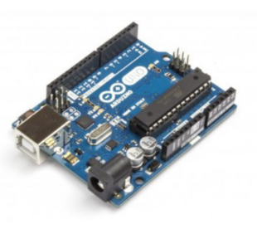

* **HC-SR04 Ultrasonic Sensor Module**: This is the sensor which measures the distance between the dustbin and any obstacle in front of the dustbin and sends data to the Arduino board for processing.

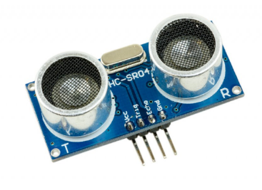

* **TowerPro MG90 Servo Motor**:Servo motor is used to open the lid of the dustbin. Servo motors are special as they can rotate at specific angles and stay there until signal is changed from the Arduino board.

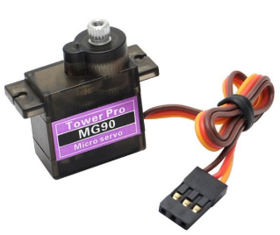

* **Connecting Wires:** They are used to join different components and complete the circuit. They are also called jumper wires and can connect an Arduino board to sensors directly.

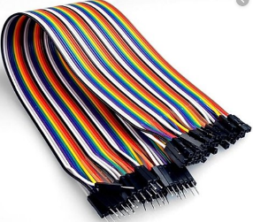

* **5V Power Supply:** Our project used a 12V DC Power supply adapter which is converted to 5V DC using a voltage regulator or step down converter LM2596 which converts 12V to 5V DC.

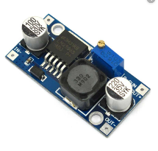

* **Dustbin and Miscellaneous (glue, plastic tube, etc.)**



**Circuit Diagram -**

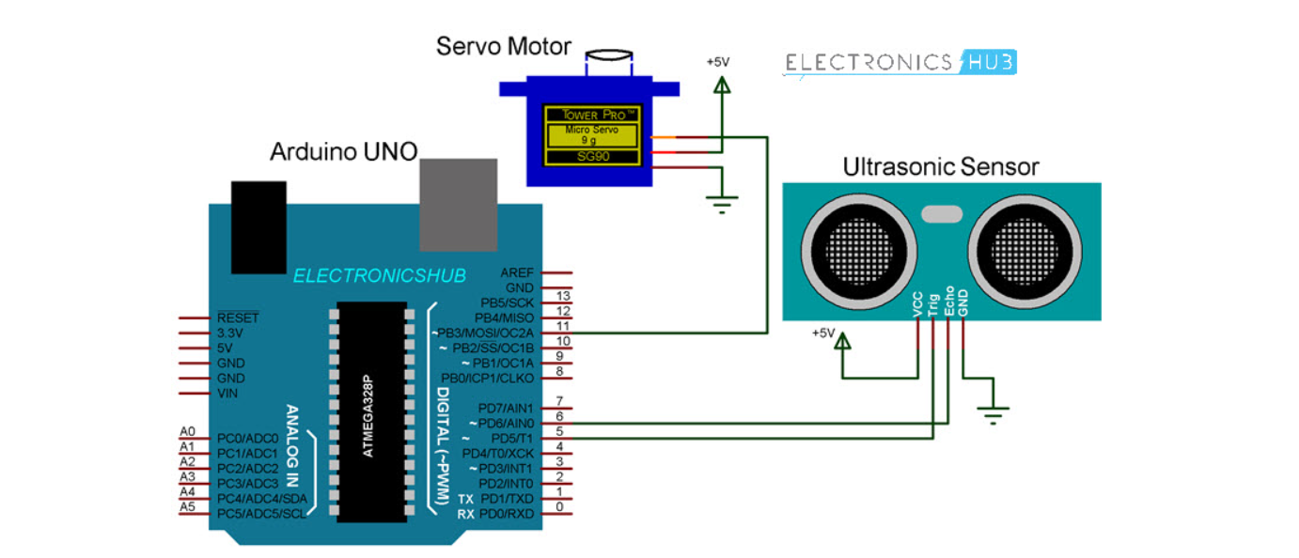

The circuit diagram of smart dustbin is shown in given below. Arduino Uno board consist ATmega328 P microcontroller, it is important component of UNO board. In this other components are present like a power supply,

ultrasonic module and servo motor etc. The ultrasonic sensor echo pin and trigger pin is connected to pin digital pin D7 and D8. The +Vcc pin is connected to +5V supply and GND pin is connected to ground pin of arduino Uno board. The control (PWM) pin of servo motor is connected to digital pin D9 of arduino. Hence, servo motor is used to open the cap of dustbin. For this project and components used, the preset level of distance between dustbin and hand is fixed to 40 cm.

***Ultrasonic Sensor***: This sensor is used in to locate the distance between the smart dustbin and hand/object come near to it. The principle behind finding distance of obstacle is sonar wave. It only detects obstacle when Trigger pin receive high pulse for the period more than 10 us. When this

sensor verifies the presence of hand (obstacle) it starts to send eight cycles of ultrasonic burst at 40 KHz and then it waits for reflected ultrasonic

signal. Ultrasonic sensor module has two drums. One of the drums is used for transmitting the pulse of ultrasonic and the second drums are for receiving

the ultrasonic signal.

When ultrasonic detect/sense object, the echo pin of module is set high. Waiting period of reflected pulse is completely dependent upon the location of obstacle. When the echo signal is obtained, we can calculate the distance by using the formula -

**Distance (in cm) = (duration/2) / 29.1**

**WORKING OF THE PROJECT**

After wiring and attaching all the devices and setting up to the Smart Dustbin, now observe all the important setup whether they are well connected or something missed.

After connection set up now next step is to submit/upload code in Arduino and supply power to the circuit.

When system is powered ON, Arduino keeps monitoring for any things that come near the sensor at give range.

When Ultrasonic sensor detect any object for example like hand or others, here Arduino calculates its distance and if it less than a certain predefines value than servo motor get activate first and with the support of the extended arm of the lid.

Lid will open for a given time than it will automatically close.

**ADVANTAGES**

Following are the advantages of using Smart dustbin:

A reduction in the number of waste collections needed by up to 80%, resulting in less manpower, emissions, fuel use and traffic congestion.

A reduction in the number of waste bins needed.

**FUTURE ENHANCEMENTS**

Here we are going to make an evolution changes toward cleanliness. The combination of intelligent waste monitoring and trash compaction technologies, smart dustbins are better and shoulders above traditional garbage dustbin.

It is equipped with smart devices like sensor, Arduino etc. Lid of the dustbin will automatically open when an object comes near to the dustbin and after certain time period it will close the lid.

For social it will help toward health and hygiene, for business for we try to make it affordable to many as many possible. So that normal people to rich people can take benefit from it.

Believe this will bring something changes in term of cleanliness as well technology. So our next work will be adding one more sensor which will sense whether our dustbin is full or not.

And there will be a display will be added so that user can notify that dustbin is full or not.

**Bibliography**-

1. <https://www.researchgate.net/publication/343530056_SMART_DUSTBIN_USING_ARDUINO>
2. <https://www.electronicshub.org/smart-dustbin-using-arduino/>